Practical Application III

The dataset from the UCI Machine Learning Repository (Bank Marketing Dataset) (dataset: https://archive.ics.uci.edu/dataset/222/bank+marketing) is appropriate for evaluating classifiers to predict whether a client will subscribe to a term deposit.
Business Objective
The objective of this project is to compare different classifiers (k-nearest neighbors, logistic regression, decision trees, and support vector machines) using the bank marketing dataset from the UCI Machine Learning Repository. The goal is to determine the most accurate and reliable model for predicting the success of a marketing campaign for a bank.

Pre-requisite of Comparison
To compare the performance of classifiers, we can follow these steps:
- Data Review
- Data Preprocessing: Convert categorical variables to numerical (one-hot encoding or label encoding).
- Train-test Split: Split the dataset into training and testing sets. It ensures that model performance is evaluated on unseen data.
- Model Training: Train the following classifiers:
  - Baseline
  - Logistic Regression Basic
  - K-Nearest Neighbors
  - Logistic Regression
  - Decision Trees
  - Support Vector Machines
- Performance Comparison: Compare the performance of the classifiers using metrics such as Train Score, Test Score and Average Fit time.
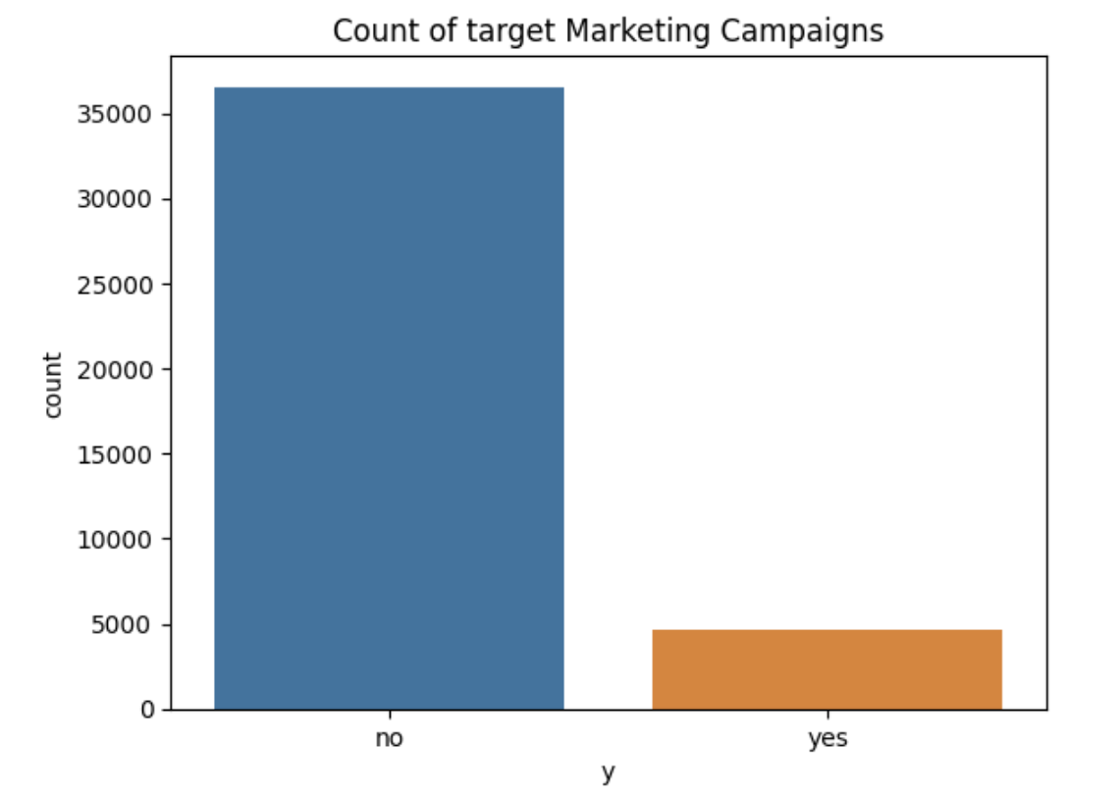
Results- Key Highlights:
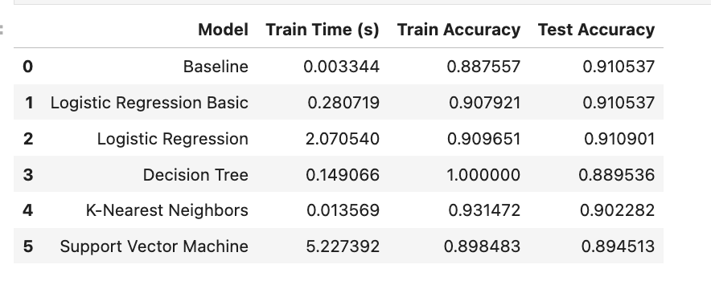
- Logistic Regression and KNN models perform the best in terms of Test and Train accuracy.
- KNN model performs best in training time (0.003 Seconds).
- SVM model (SVC classifier) has the highest training time and is computationally expensive.
- Bank Marketing dataset is impbalanced because distribution is not similar within dataset.
- The highest positive correlation between numerical independent variables is between "emp.var.rate" and "euribor3m" with a value of 0.97.
- The highest negative correlation between numerical independent variables is between "pdays" and "previous" with a value of -0.59.
- The "Day_of_Week" feature has a similar success rate among all categorical values, so it is not an important feature for the given model dataset.
- The "nr.employed" & "euribor3m" are higher importance features since they have higher influence towards model predictions.
- The "month", "cons.price.idx" and "duration" features have higher coefficient, and they contribute higher towards predicting the target variable.
- Overall, the Logistic Regression model is the best performing model among all four models followed by KNN model.
These results suggest that Logistic Regression and KNN are likely better choices for this dataset, as they balance accuracy and computational efficiency.

• The results mention that Logistic Regression and KNN performed best, which aligns with typical findings for this dataset. These models balance computational efficiency and performance.
• SVM is computationally expensive, which was also noted in the document. This can be mitigated by using more efficient kernels or simplifying the feature set.
• The observation about dataset imbalance is important. The document could benefit from elaborating on strategies such as SMOTE or undersampling to address the imbalance, as noted in the "Next Steps" section.

Improve the Results:
  - Scaling and Normalization:
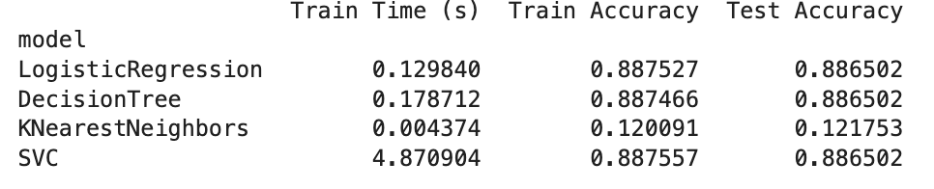
- More feature engineering and exploration: following features can be dropped due to their low correlation with the target variable:
- Age, marital, housing, job, day_of_week, loan, month, campaign, default, contact
- Hyperparameter tuning and grid search.
- Adjust your performance metric

  - More Feature Engineering and Exploration:
Following features can be dropped due to their low correlation with the target variable:
- Age, marital, housing, job, day_of_week, loan, month, campaign, default, contact
- High Strong Positive Correlation (Above 0.8):
euribor3m, nr.employed, and emp.var.rate are likely to be highly correlated
- High Negative Correlation (Below -0.5):
pdays and previous might also be highly correlated.
- Features to Consider Dropping or Transforming:
age and campaign
Features with Near-Zero Variance: Remove features that have little variability across the dataset.

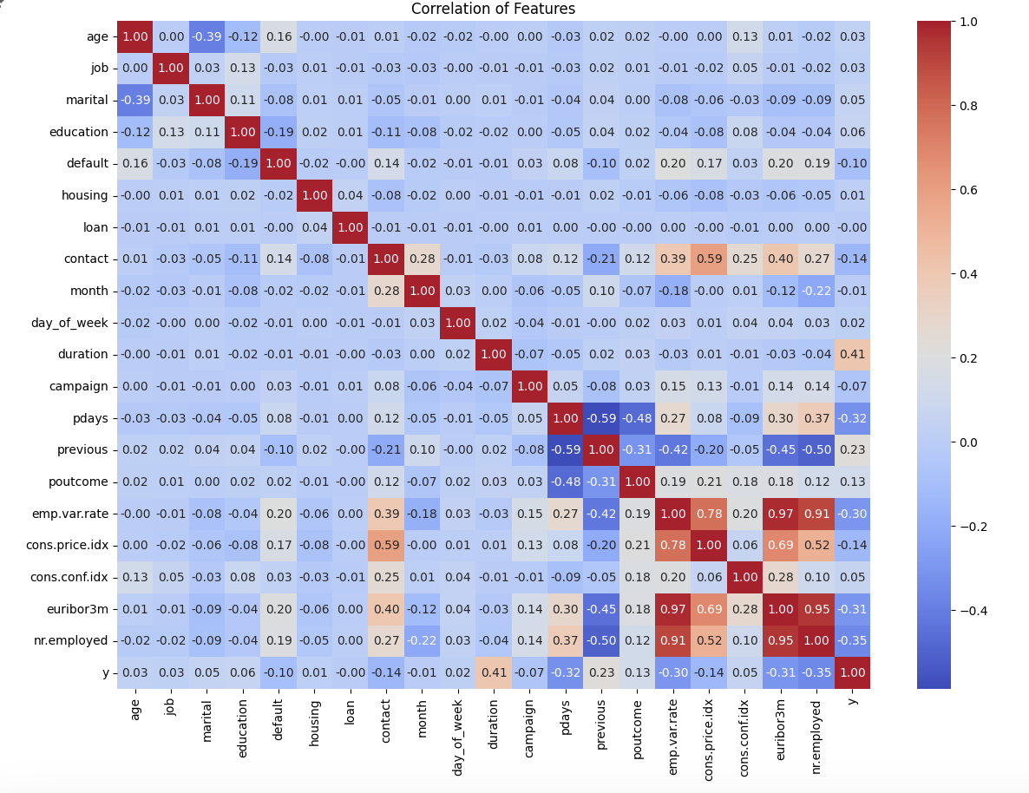

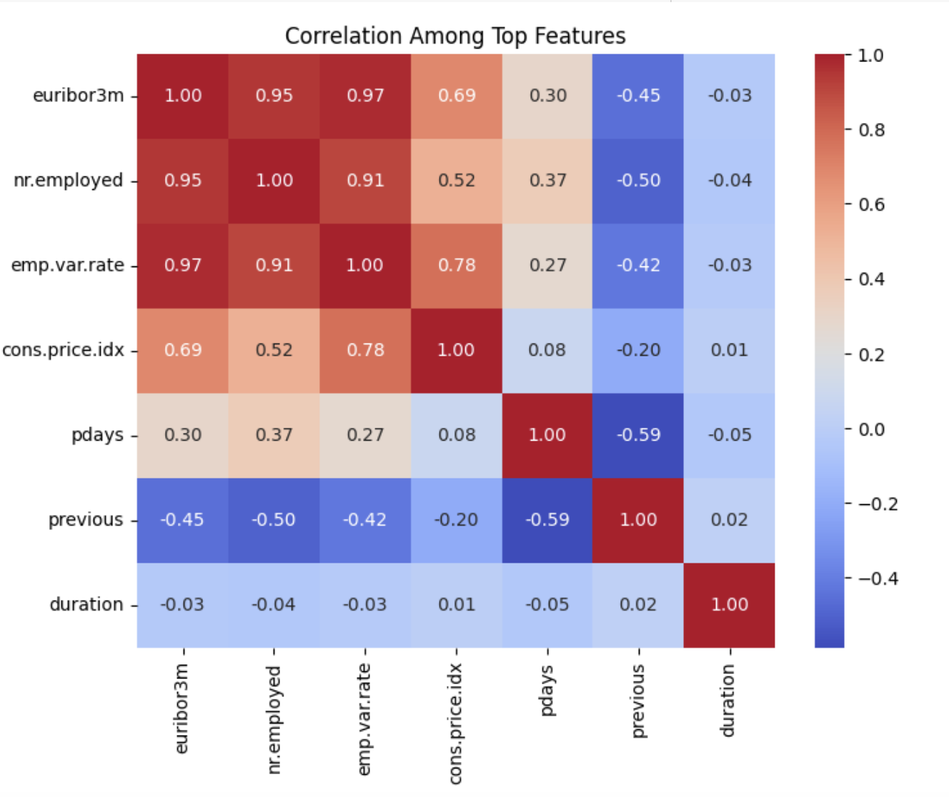
  - Hyperparameter tuning and GridSearch
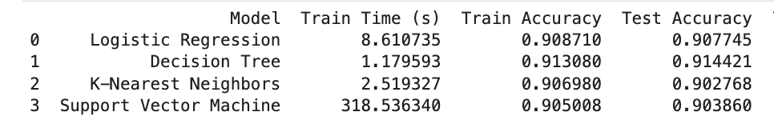
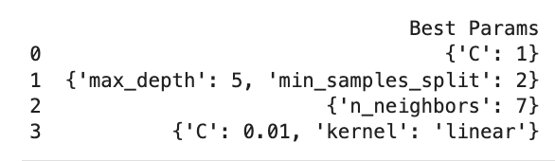
Insights from Tuning:
- Decision Tree emerges as the best performer in terms of test accuracy (0.9144) and train time (1.18 seconds). The optimal tree depth of 5 ensures that the model does not overfit, and the training time is remarkably fast.
- Logistic Regression strikes a good balance between accuracy and training time, with test accuracy (0.9077) and a reasonable train time (8.61 seconds). It's a strong alternative for this dataset, especially when computational efficiency is a concern.
- K-Nearest Neighbors shows reasonable performance but is outperformed by Decision Tree and Logistic Regression. KNN is also computationally more expensive during prediction as it requires calculating distances for all training points.
- Support Vector Machine has comparable accuracy but suffers from a prohibitively high training time, making it less practical for this dataset unless training time can be reduced.

Next steps and Recommendations
- Evaluate and identify non-important categorical features in a group (with other feature variable) rather than single to determine whether there exists combination of categorical features which can be discarded.
- Continue to add samples from new marketing campaign and evaluate the different classifier models.
- Imbalanced dataset: Since the bank marketing dataset is imbalanced, consider using techniques such as resampling, SMOTE, undersampling and class weighting are good strategies for improving performance on imbalanced datasets.
- Training time and computational expense: Given that the SVM model (SVC classifier) has the highest training time and is computationally expensive, consider optimizing the model or exploring alternative models that can provide similar performance with lower training time. This can be mitigated by using more efficient kernels or simplifying the feature set.
- Correlation analysis: Take note of the highest positive correlation between "emp.var.rate" and "euribor3m" and the highest negative correlation between "pdays" and "previous". These insights can help in understanding the relationships between variables and potentially identifying multicollinearity issues. We might consider using PCA to combine highly correlated features or regularization techniques like Lasso or Ridge.
- For Decision Tree, trying ensemble methods like Random Forest or Gradient Boosting could yield even better results by reducing overfitting and improving generalization.
- We can tune KNN n_neighbors in combination with other distance metrics (e.g., weights = 'distance') to improve performance.

